

Data Structures and Algorithms
( Course Code: CSC211 )

Name: Muhammad Abdullah
Roll No # FA24-BSE-042
Instructor Name: Sir Atique Ahmad

Lab Assignment# 2

Task 1:
Code:
// Return Management System using Stack
#include <iostream>
using namespace std;

const int MAX_SIZE = 100; // Maximum number of static array

struct ReturnRequest {
int orderID;
string customerName;
string returnReason;
string dateOfReq;
};

class ReturnSystem {
private:
ReturnRequest stack[MAX_SIZE];
int top;
public:
ReturnSystem() : top(-1) {}

void pushReturnReq(int orderID, string customerName, string returnReason, string dateOfReq) {
if (top >= MAX_SIZE - 1) {
cout << "Stack Overflow: Cannot add more return requests." << endl;
return;
}
top++;
stack[top].orderID = orderID;
stack[top].customerName = customerName;
stack[top].returnReason = returnReason;
stack[top].dateOfReq = dateOfReq;
}

void popReturnReq() {
if (top == -1) {
cout << "No Requests in the stack." << endl;
return;
}
cout << "This returnID is removed: " << stack[top].orderID << endl;
top--;
}

void peekReturnReq() {
if (top == -1) {
cout << "No Requests in the stack." << endl;
return;
}
cout << "This is the Last Return Request: " << stack[top].orderID << " By " << stack[top].customerName << endl;
}

void displayAllRequests() {
if (top == -1) {
cout << "No Requests in the stack." << endl;
return;
}
for (int i = top; i >= 0; --i) {
cout << stack[i].orderID << " -> ";
}
cout << "Null" << endl;
}
};

int main () {
ReturnSystem rms;

rms.pushReturnReq(1, "Abdullah", "not good", "20/10/25");
rms.pushReturnReq(101, "Abbas", "damaged item", "2024/06/01");
rms.pushReturnReq(102, "Hashim", "wrong size", "2024/06/02");
rms.pushReturnReq(103, "Kiran", "late delivery", "2024/06/03");

rms.displayAllRequests();
rms.popReturnReq();
rms.displayAllRequests();
rms.peekReturnReq();

return 0;
}

Output:

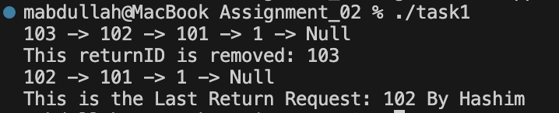

Task 2:
Code:
// Browser Navigation using Stack
#include <iostream>
#include <ctime>
using namespace std;

struct Node {
string pageTitle;
string URL;
int timeVisited;
Node* prev;
Node* next;

Node(string pageTitle, string URL ,int timeVisited): pageTitle(pageTitle), URL(URL), timeVisited(timeVisited), prev(nullptr), next(nullptr) {};
};

class BrowserNavigation {
private:
Node* head;
Node* tail;
Node* temp;

public:
BrowserNavigation() {
head = nullptr;
tail = nullptr;
temp = nullptr;
}

void visitPage(string pageTitle, string URL, int time) {
Node* newNode = new Node(pageTitle, URL, time);
if(head == nullptr) {
head = newNode;
tail = newNode;
} else {
head->next = newNode;
newNode->prev = head;
head = newNode;
}
}

void goBack() {
if (head == nullptr) {
cout << "Navigation Stack is empty." << endl;
return;
}
temp = head;
head = head->prev;
if(head != nullptr) {
head->next = nullptr;
} else {
tail = nullptr;
}

if(head != nullptr) {
cout << " ---- Going Back ----" << endl;
cout << "Going back to: " << head->URL << endl;
} else{
cout << " ---- Going Back ----" << endl;
cout << "No previous page." << endl;
}
}
void goForward() {
if (temp == nullptr) {
cout << " ---- Going Back ----" << endl;
cout << "No forward pages available." << endl;
return;
}
head->next = temp;
temp->prev = head;
head = temp;
cout << " ---- Going Forward ----" << endl;
cout << "Going forward to: " << head->URL << endl;
}

void viewCurrentPage() {
if (head == nullptr) {
cout << "No current page to display." << endl;
return;
}
cout << " ---- Current Page ----" << endl;
cout << "Title: " << head->pageTitle << endl;
cout << "URL: " << head->URL << endl;
cout << "Time visited: " << head->timeVisited << endl;
}

void displayHistory() {
Node* current = head;
if (current == nullptr) {
cout << "No browsing history." << endl;
return;
}
cout << " ---- Browsing History ----" << endl;
while (current != nullptr) {
cout << "Title: " << current->pageTitle << ", URL: " << current->URL << endl;
current = current->prev;
}
}
};

int main () {
BrowserNavigation bn;

// Geting time ( trying to get :) )
int currentTime = time(0);

bn.visitPage("Google", "https://www.google.com", currentTime);
bn.visitPage("YouTube", "https://www.youtube.com", currentTime);
bn.visitPage("GitHub", "https://github.com", currentTime);
bn.visitPage("Wikipedia", "https://www.wikipedia.org", currentTime);

bn.viewCurrentPage();
bn.displayHistory();
bn.goBack();
bn.displayHistory();
bn.goForward();
bn.displayHistory();

return 0;
}

Output:

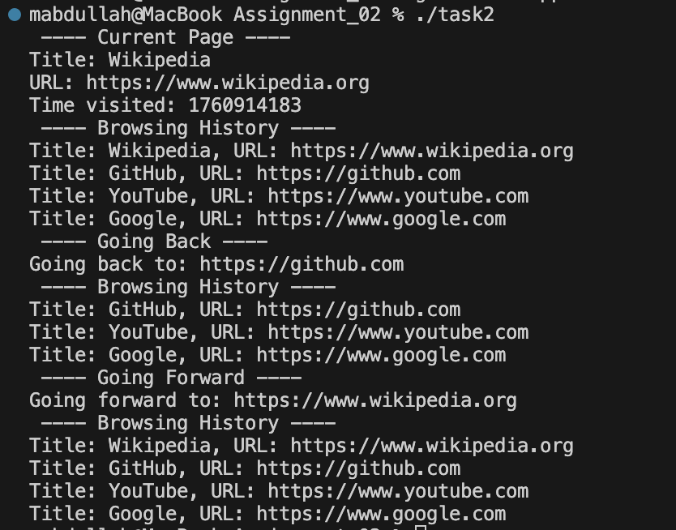

Task 3:
Code:
#include <iostream>
#include <stack>
#include <string>
using namespace std;

class PostFix {
public:
int postFix(const string& expression) {
stack<int> s;

for (char c : expression) {
if (c == ' ')
continue;
if (c >= '0' && c <= '9') {
s.push(c - '0');
}
else if (c == '+' || c == '-' || c == '*' || c == '/') {
if (s.size() < 2) {
cerr << "Error: Not enough operands." << endl;
return 0;
}
int n2 = s.top(); s.pop();
int n1 = s.top(); s.pop();
int result = 0;
switch (c) {
case '+': result = n1 + n2; break;
case '-': result = n1 - n2; break;
case '*': result = n1 * n2; break;
case '/':
if (n2 == 0) {
cerr << "Error: Division by zero." << endl;
return 0;
}
result = n1 / n2;
break;
}
s.push(result);
} else {
cerr << "Error: Invalid character '" << c << "'." << endl;
return 0;
}
}
if (s.size() == 1)
return s.top();
else {
cerr << "Error: Invalid postfix expression." << endl;
return 0;
}
}
};

int main() {
PostFix pf;
int result = pf.postFix("23-4+567*+*");
cout << "Result: " << result << endl;
return 0;
}

Output:

Task 4:
Code:

#include <iostream>
using namespace std;

struct Node {
string boxNumber;
int boxWeight;
Node *prev;
Node(string num, int wt) : boxNumber(num), boxWeight(wt), prev(nullptr) {}
};

class LogisticsSystem {
private:
Node *top;

public:
LogisticsSystem() : top(nullptr) {}

void placeBox(string boxNumber, int boxWeight) {
Node *newNode = new Node(boxNumber, boxWeight);

// Popping until we find a heavier or equal box
while (top != nullptr && boxWeight > top->boxWeight) {
Node *temp = top;
top = top->prev;
delete temp;
}

newNode->prev = top;
top = newNode;
}

void displayBoxList() {
if (top == nullptr) {
cout << "No boxes in the system.\n";
return;
}

cout << "---- Stack from Top (lightest) to Bottom (heaviest) ----\n";
Node *current = top;
while (current != nullptr) {
cout << "Box Number: " << current->boxNumber
<< ", Box Weight: " << current->boxWeight << endl;
current = current->prev;
}
}
};

int main() {
LogisticsSystem ls;

ls.placeBox("B101", 50);
ls.placeBox("B102", 40);
ls.placeBox("B103", 35);
ls.placeBox("B104", 25);
ls.placeBox("B105", 5);
ls.placeBox("B106",36);

ls.displayBoxList();
return 0;
}

Output:

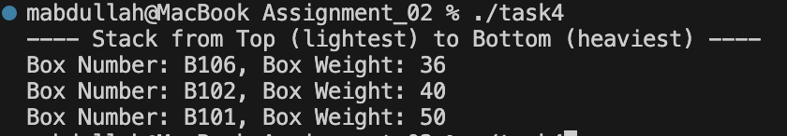

Task 5:
Code:
#include <iostream>
using namespace std;

const int MAX_SIZE = 50;

struct Passenger {
string passengerName;
string destination;
string ticketType;
};

class AirportManagementSystem {
private:
Passenger queue[MAX_SIZE];
int front; // front element (1,2,4,5), it points to 1 because 1 came first. FIFO
int rear; // last element

public:
AirportManagementSystem() : front(-1), rear(-1) {}

bool isFull() {
return (rear == MAX_SIZE - 1);
}

bool isEmpty() {
return (front == -1 || front > rear);
}

void enqueuePassenger(string passengerName, string destination, string ticketType) {
if (isFull()) {
cout << "Queue Overflow: Cannot add more passengers.\n";
return;
}

if (front == -1) front = 0;

rear++;
queue[rear].passengerName = passengerName;
queue[rear].destination = destination;
queue[rear].ticketType = ticketType;

cout << "Passenger Enqueued: " << passengerName << endl;
}

void dequeuePassenger() {
if (isEmpty()) {
cout << "No Passengers in the queue.\n";
return;
}

cout << "Passenger Dequeued: " << queue[front].passengerName << endl;
front++;

if (front > rear) {
front = rear = -1; // reset queue when empty
}
}

void peekReturnReq() {
if (isEmpty()) {
cout << "No Passengers in the queue.\n";
return;
}
cout << "Next Passenger in Line: " << queue[front].passengerName
<< " → " << queue[front].destination << endl;
}

void displayQueue() {
if (isEmpty()) {
cout << "No Requests in the queue.\n";
return;
}

cout << "---- Current Queue ----\n";
for (int i = front; i <= rear; i++) {
cout << i + 1 << ". " << queue[i].passengerName
<< " → " << queue[i].destination
<< " (" << queue[i].ticketType << ")\n";
}
}
};

int main() {
AirportManagementSystem ams;

ams.enqueuePassenger("John", "New York", "VIP");
ams.enqueuePassenger("Jane", "Los Angeles", "Regular");
ams.enqueuePassenger("Jim", "Chicago", "VIP");
ams.enqueuePassenger("Jill", "Houston", "Regular");
ams.enqueuePassenger("Jack", "Miami", "VIP");

cout << endl;
ams.displayQueue();

cout << endl;
ams.dequeuePassenger();

cout << endl;
ams.displayQueue();

cout << endl;
ams.peekReturnReq();

return 0;
}

Output:

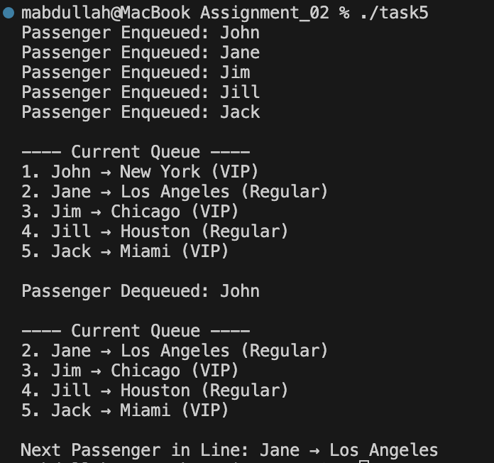

Task 6:
Code:
// Hospital Management System Using Queue
#include <iostream>
using namespace std;

struct Node {
int patientID;
string patientName;
string doctorName;
string appointmentTime;
Node* prev;
Node* next;

Node(int patientID, string patientName, string doctorName ,string appointmentTime): patientID(patientID), patientName(patientName), doctorName(doctorName), appointmentTime(appointmentTime), prev(nullptr), next(nullptr) {};
};

class HospitalManagementSystem {
private:
Node* head;
Node* tail;

public:
HospitalManagementSystem () {
head = nullptr;
tail = nullptr;
}

void addPatient(int patientID, string patientName, string doctorName ,string appointmentTime) {
Node* newNode = new Node(patientID, patientName, doctorName, appointmentTime);
if(head == nullptr) {
head = tail = newNode;
} else {
head->prev = newNode;
newNode->next = head;
head = newNode;
}
}

void callNextPatient() {
if (head == nullptr) {
cout << "Patient Queue is empty." << endl;
return;
}
Node* temp = head;
head = head->next;
if(head != nullptr) {
head->prev = nullptr;
} else {
tail = nullptr;
}

cout << " ---- Next Patient ----" << endl;
cout << "Next Patient is: " << head->patientName << endl;

delete temp;
}

void displayAllAppointments() {
Node* current = head;
if (current == nullptr) {
cout << "No appointments." << endl;
return;
}
cout << " ---- All Appointments ----" << endl;
while (current != nullptr) {
cout << "Patient ID: " << current->patientID << ", Doctor: " << current->doctorName
<< ", Patient Name: " << current->patientName
<< ", Appointment Time: " << current->appointmentTime << endl;
current = current->next;
}
}
};

int main () {
HospitalManagementSystem hms;

hms.addPatient(1, "John Doe", "Dr. Smith", "09:00 AM");
hms.addPatient(2, "Jane Doe", "Dr. Adams", "09:30 AM");
hms.addPatient(3, "Alice Brown", "Dr. Miller", "10:00 AM");
hms.addPatient(4, "Bob Green", "Dr. Lee", "10:30 AM");

hms.displayAllAppointments();
hms.callNextPatient();
hms.displayAllAppointments();
hms.callNextPatient();
hms.displayAllAppointments();
hms.callNextPatient();

return 0;
}

Output:

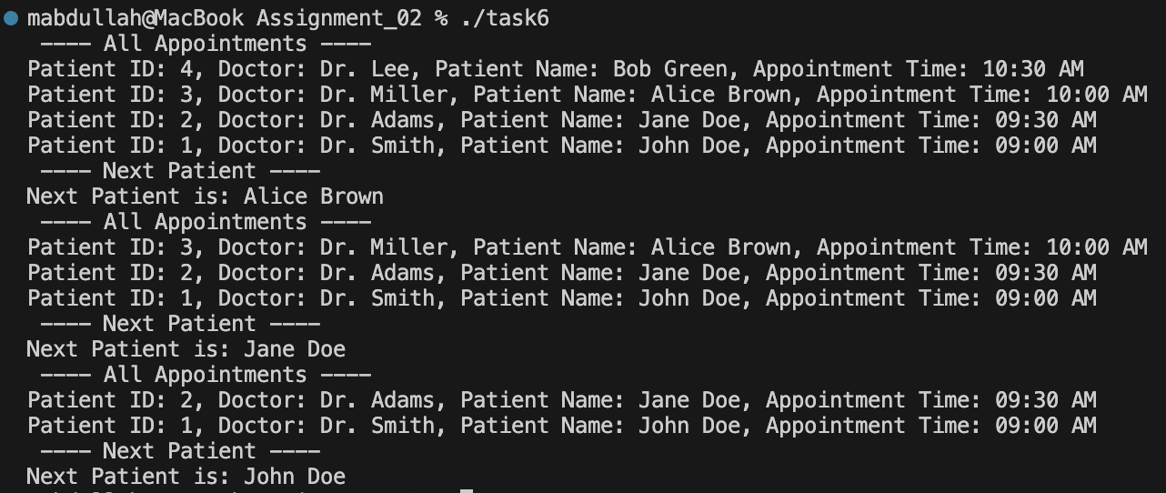

Task 7:
Code:
#include <iostream>
using namespace std;

const int MAX_SLOTS = 5;

struct Car {
string carNumber;
int slotNumber;
};

class ParkingLot {
private:
Car parkingLot[MAX_SLOTS];
int front;
int rear;
int count;
public:
ParkingLot() {
front = 0;
rear = -1;
count = 0;
}

bool isFull() const {
return count == MAX_SLOTS;
}

bool isEmpty() const {
return count == 0;
}

void parkCar(const string& carNumber) {
if (isFull()) {
cout << "Parking Lot Full! Cannot park " << carNumber << endl;
return;
}
rear = (rear + 1) % MAX_SLOTS;
parkingLot[rear].carNumber = carNumber;
parkingLot[rear].slotNumber = rear + 1;
count++;
cout << "Car " << carNumber << " parked at slot " << parkingLot[rear].slotNumber << endl;
}

void removeCar() {
if (isEmpty()) {
cout << "No cars to remove.\n";
return;
}
cout << "Car " << parkingLot[front].carNumber
<< " leaving from slot " << parkingLot[front].slotNumber << endl;
front = (front + 1) % MAX_SLOTS;
count--;
}

void displayParkingStatus() const {
if (isEmpty()) {
cout << "Parking lot empty.\n";
return;
}
cout << "\n--- Parking Lot Status ---\n";
for (int i = 0; i < count; i++) {
int index = (front + i) % MAX_SLOTS;
cout << "Slot " << parkingLot[index].slotNumber
<< " -> Car: " << parkingLot[index].carNumber << endl;
}
cout << "---------------------------\n";
}
};

int main() {
ParkingLot pl;
pl.parkCar("ABC-123");
pl.parkCar("XYZ-789");
pl.parkCar("LMN-456");
pl.parkCar("JKL-999");
pl.parkCar("QWE-222");
pl.parkCar("QTY-123");

pl.displayParkingStatus();

cout << "\n--- Removing Two Cars ---\n";
pl.removeCar();
pl.removeCar();
pl.displayParkingStatus();

cout << "\n--- Parking New Cars ---\n";
pl.parkCar("TUV-333");
pl.parkCar("RTY-444");
pl.displayParkingStatus();

return 0;
}

Output:
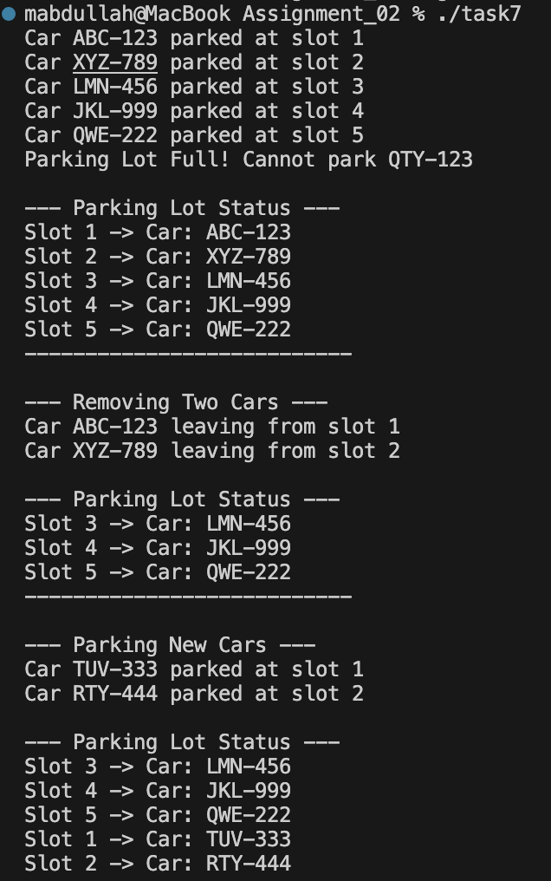

Task 8:
Code:
#include <iostream>
using namespace std;

const int MAX_SEATS = 5;

struct Passenger {
string name;
string category;
int seatNumber;
};

class TrainReservation {
private:
Passenger queue[MAX_SEATS];
int front;
int rear;
int count;

public:
TrainReservation() {
front = 0;
rear = -1;
count = 0;
}

bool isFull() const {
return count == MAX_SEATS;
}

bool isEmpty() const {
return count == 0;
}

void bookAtFront(const string& name, const string& category) {
if (isFull()) {
cout << "Reservation Full! Cannot add passenger: " << name << endl;
return;
}

// Move front backward circularly
front = (front - 1 + MAX_SEATS) % MAX_SEATS;
queue[front].name = name;
queue[front].category = category;
queue[front].seatNumber = front + 1;
count++;

cout << "Passenger " << name << " booked at seat " << queue[front].seatNumber << endl;
}

void bookAtRear(const string& name, const string& category) {
if (isFull()) {
cout << "Reservation Full! Cannot add passenger: " << name << endl;
return;
}

// Move rear forward circularly
rear = (rear + 1) % MAX_SEATS;
queue[rear].name = name;
queue[rear].category = category;
queue[rear].seatNumber = rear + 1;
count++;

cout << "Passenger " << name << " booked at seat " << queue[rear].seatNumber << endl;
}

void cancelFromFront() {
if (isEmpty()) {
cout << "No reservations to cancel from front.\n";
return;
}

cout << "Cancelled reservation of " << queue[front].name
<< " (Seat " << queue[front].seatNumber << ")" << endl;

front = (front + 1) % MAX_SEATS;
count--;
}

void cancelFromRear() {
if (isEmpty()) {
cout << "No reservations to cancel from rear.\n";
return;
}

cout << "Cancelled reservation of " << queue[rear].name
<< " (Seat " << queue[rear].seatNumber << ")" << endl;

rear = (rear - 1 + MAX_SEATS) % MAX_SEATS;
count--;
}

void displayAllReservations() const {
if (isEmpty()) {
cout << "No reservations.\n";
return;
}

cout << "\n--- Train Reservation List ---\n";
for (int i = 0; i < count; i++) {
int index = (front + i) % MAX_SEATS;
cout << "Seat " << queue[index].seatNumber
<< " -> " << queue[index].name
<< " (" << queue[index].category << ")\n";
}
cout << "-------------------------------\n";
}
};

int main() {
TrainReservation tr;

tr.bookAtRear("Ali", "Regular");
tr.bookAtRear("Ahmed", "Regular");
tr.bookAtFront("Sara", "VIP");
tr.bookAtRear("Zain", "Regular");
tr.bookAtFront("Maryam", "VIP");

tr.displayAllReservations();

cout << "\n--- Cancelling One from Front and One from Rear ---\n";
tr.cancelFromFront();
tr.cancelFromRear();

tr.displayAllReservations();

cout << "\n--- Adding New Bookings ---\n";
tr.bookAtFront("Hassan", "VIP");
tr.bookAtRear("Usman", "Regular");

tr.displayAllReservations();

return 0;
}

Output:
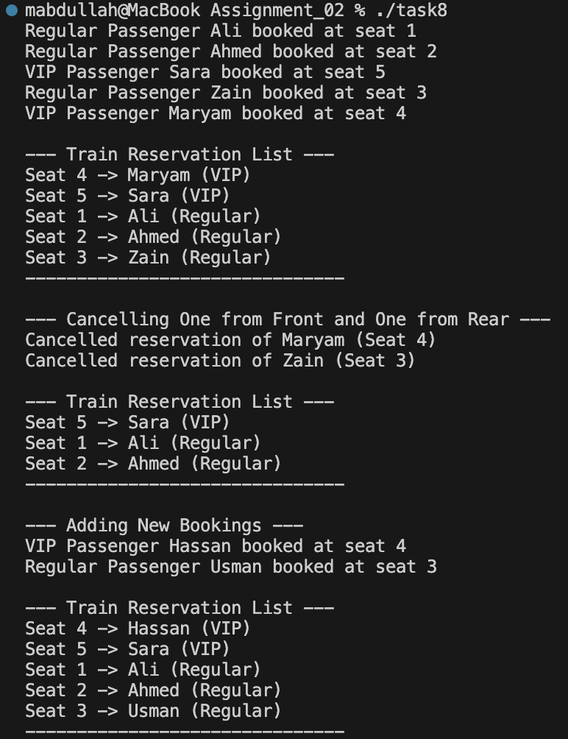
Task 9:
Code:
#include <iostream>
using namespace std;

const int MAX_PATIENTS = 10;

struct Patient {
int patientID;
string name;
string condition;
int priority;
};

class EmergencyRoom {
private:
Patient queue[MAX_PATIENTS];
int count;

public:
EmergencyRoom() {
count = 0;
}

bool isFull() const {
return count == MAX_PATIENTS;
}

bool isEmpty() const {
return count == 0;
}

void addPatient(int id, const string& name, const string& condition, int priority) {
if (isFull()) {
cout << "ER Full! Cannot admit new patient: " << name << endl;
return;
}

Patient newPatient = {id, name, condition, priority};

// According to priority
int i = count - 1;
while (i >= 0 && queue[i].priority > newPatient.priority) {
queue[i + 1] = queue[i]; // shift right
i--;
}

queue[i + 1] = newPatient;
count++;

cout << "Patient " << name << " (Priority " << priority << ") added.\n";
}

void treatPatient() {
if (isEmpty()) {
cout << "No patients to treat.\n";
return;
}

cout << "Treating Patient: " << queue[0].name
<< " | Condition: " << queue[0].condition
<< " | Priority: " << queue[0].priority << endl;

for (int i = 0; i < count - 1; i++) {
queue[i] = queue[i + 1];
}
count--;
}

void displayAllPatients() const {
if (isEmpty()) {
cout << "No patients in queue.\n";
return;
}

cout << "\n--- ER Waiting List (High → Low Priority) ---\n";
for (int i = 0; i < count; i++) {
cout << "ID: " << queue[i].patientID
<< " | Name: " << queue[i].name
<< " | Priority: " << queue[i].priority
<< " | Condition: " << queue[i].condition << endl;
}
}
};

int main() {
EmergencyRoom er;

// Arrivals in order: 4, 1, 3, 2
er.addPatient(101, "Ali", "Minor Injury", 4);
er.addPatient(102, "Sara", "Heart Attack", 1);
er.addPatient(103, "Ahmed", "Fracture", 3);
er.addPatient(104, "Zain", "High Fever", 2);

er.displayAllPatients();

cout << "\n--- Treatment Sequence ---\n";
while (!er.isEmpty()) {
er.treatPatient();
}

return 0;
}

Output:

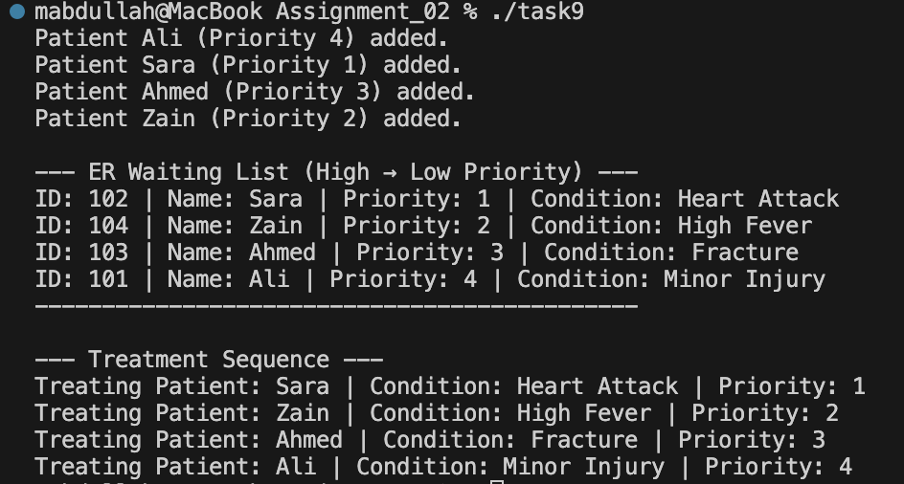

Task 10:
Code:
#include <iostream>
using namespace std;

const int MAX = 10;

struct Order {
int orderID;
string restaurant;
string customer;
string items;
int prepTime;
string orderTime;
};

class DeliveryQueue {
private:
Order queue[MAX];
int front, rear, count;

public:
DeliveryQueue() {
front = 0;
rear = -1;
count = 0;
}

bool isFull() {
return count == MAX;
}

bool isEmpty() {
return count == 0;
}

void addOrder(int id, string rest, string cust, string items, int prep, string time) {
if (isFull()) {
cout << "Queue is full. Cannot add more orders.\n";
return;
}

Order o = {id, rest, cust, items, prep, time};

// quick order -> add at front, else at rear
if (prep <= 10) {
front = (front - 1 + MAX) % MAX;
queue[front] = o;
} else {
rear = (rear + 1) % MAX;
queue[rear] = o;
}
count++;
cout << "Order " << id << " added (" << (prep <= 10 ? "Quick" : "Normal") << ").\n";
}

void dispatchOrder() {
if (isEmpty()) {
cout << "No orders to dispatch.\n";
return;
}
cout << "Dispatching Order " << queue[front].orderID
<< " from " << queue[front].restaurant << endl;
front = (front + 1) % MAX;
count--;
}

void viewNextOrder() {
if (isEmpty()) {
cout << "No pending orders.\n";
return;
}
Order o = queue[front];
cout << "\nNext Order to dispatch:\n";
cout << "Order ID: " << o.orderID << endl;
cout << "Restaurant: " << o.restaurant << endl;
cout << "Customer: " << o.customer << endl;
cout << "Items: " << o.items << endl;
cout << "Prep Time: " << o.prepTime << " mins" << endl;
cout << "Order Time: " << o.orderTime << endl;
}

void displayAllOrders() {
if (isEmpty()) {
cout << "No pending orders.\n";
return;
}
cout << "\n--- Current Queue ---\n";
int i = front;
for (int c = 0; c < count; c++) {
cout << "Order " << queue[i].orderID << " | " << queue[i].restaurant
<< " | Prep: " << queue[i].prepTime << " mins | Customer: " << queue[i].customer << endl;
i = (i + 1) % MAX;
}
cout << endl;
}

void cancelOrder(int id) {
if (isEmpty()) {
cout << "Queue is empty.\n";
return;
}
int i = front;
bool found = false;
for (int c = 0; c < count; c++) {
if (queue[i].orderID == id) {
found = true;
cout << "Cancelling Order " << id << endl;
for (int j = c; j < count - 1; j++) {
queue[(front + j) % MAX] = queue[(front + j + 1) % MAX];
}
rear = (rear - 1 + MAX) % MAX;
count--;
break;
}
i = (i + 1) % MAX;
}
if (!found) cout << "Order not found.\n";
}
};

int main() {
DeliveryQueue d;

d.addOrder(101, "McDonalds", "House 12", "Burger, Fries", 8, "12:30");
d.addOrder(102, "KFC", "Street 5", "Zinger", 15, "12:35");
d.addOrder(103, "Subway", "House 21", "Sandwich", 5, "12:40");
d.addOrder(104, "Pizza Hut", "Block B", "Pizza", 20, "12:45");

d.displayAllOrders();

cout << "\nDispatching 2 orders:\n";
d.dispatchOrder();
d.dispatchOrder();

d.displayAllOrders();

cout << "\nCancelling Order 104:\n";
d.cancelOrder(104);

d.displayAllOrders();

return 0;
}

Output:

